THANKSGIVING FOOD DRIVE

Monday: Canned fruits and vegetables
Tuesday: Pasta and rice
Wednesday: Canned meat and alternatives
Thursday: Pasta sauce/Soup and Personal Care Items
  - Happy Thanksgiving
  - We are Called to Love and Be Loved

“give thanks to the lord, for he is good; his love endures forever.” (1 chronicles 16:24) |  | october 2017

GO Gold for Childhood Cancer
Our staff and students wore gold on September 25th to raise awareness of childhood cancer. We also painted rocks with gold paint and left our thumbprints. Our rocks are displayed in our front gardens.

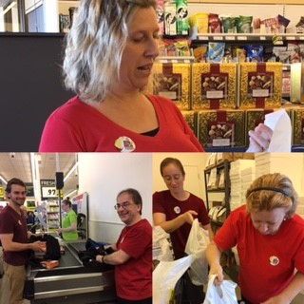
Food for Learning
St. Michael staff taking part in Food for Learning’s “Take a Bite Out of Hunger” campaign on Saturday, September 30th. A special thank you to those who were able to join us and support this wonderful cause.
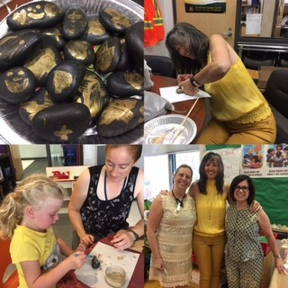
Donations and volunteers are always welcome for our breakfast program.
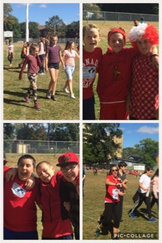

Terry Fox Run
Students enjoyed our annual Terry Fox Run on September 28th. Thank you for your active participation!

French is fun!
“Something that I really enjoyed in French class was all the collaboration. J’aime travailler avec mes amis.”
-Avery, ALCDSB Grade 9 Student

Encourage your child to be a lifelong learner of French!

catholic school council

Please consider joining our Catholic School Council. We are always looking for new members! Next meeting will be Wednesday, October 4th at 5:30 pm in the Learning Commons. All are welcome to attend!

SPIRIT WEAR IS COMING TO ST. MICHAEL!!!!!!
Information will be coming home with your child on
Mon., Oct. 2nd. All orders will be here in time for Christmas!
You can begin ordering online on Oct. 2nd. Check out the variety of clothing, hats and toques!
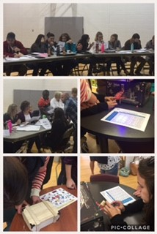

School Improvement Planning

School Improvement Planning is a whole-school team effort! Staff engaged in Health & Safety and School Improvement Planning on the September 29th PA Day. Working together to improve student achievement and student engagement in learning. Also had some time for fun and team-building with Break Out boxes!

Friday, October 13th

Algonquin and Lakeshore Catholic Education Foundation is a registered charity that raises funds and provides financial support to assist families within our schools during times of crisis or poverty. This assistance may include the provision of eye glasses, medical supplies, accommodations, food, clothing, or transportation. For more information, go to:
http://www.alcdsb.on.ca/Board/Pages/Foundation.aspx

Friday, October 27th
GRADE 7 VACCINATIONS – Hepatitis B, Meningitis, and HPV
Monday, October 16th

St. Michael Youth Group will be meeting each Tuesday in our Learning Commons. It is open to students in Grades 6-8. All students in these grades are welcome to join. The first meeting will be Tues., Oct. 3rd.
Bus Safety Presentations for all students on October 30th.

Happy Thanksgiving to all of our families!

Lorem ipsum dolor sit amet, consectetur adipiscing elit. Nullam sed luctus tellus. Pellentesque in dolor sapien, vitae dictum massa. Aenean vitae lorem dui. Morbi tempus lacinia nisi, vel scelerisque nibh facilisis id. Integer urna tortor, ullamcorper aliquet viverra non, mollis sed dolor.
Donec nunc velit, pretium eu pellentesque eget, mollis vel arcu.
Suspendisse vel purus nec erat pellentesque commodo. Aliquam tempus aliquam mauris vel dapibus. Nullam at metus erat, in convallis massa. Aliquam erat volutpat. Praesent ultrices odio in elit fringilla id rutrum mi mattis.
Duis purus eros, aliquam eu cursus tincidunt, feugiat vitae magna. Etiam sodales consequat nibh, eget rhoncus metus convallis et. Morbi rutrum mollis facilisis. Aenean faucibus
Morbi tempus lacinia nisi, vel scelerisque nibh facilisis id. Integer urna tortor, ullamcorper aliquet viverra non, mollis sed dolor. Etiam sodales consequat nibh, eget rhoncus metus convallis et.
Phasellus dignissim nulla at diam fermentum in sollicitudin sem condimentum. Pellentesque condimentum diam et sem rhoncus semper sed at libero. Aenean condimentum, lorem vel faucibus pellentesque, quam nunc lacinia augue, vel sagittis dolor ipsum vitae velit. Ut feugiat odio ac dolor iaculis consequat. Praesent sed lacus ante. Nullam pretium commodo libero, at congue sapien dignissim a. Cum sociis natoque penatibus et magnis dis parturient montes, nascetur ridiculus mus. In hac habitasse platea dictumst. Vestibulum ante ipsum primis in faucibus orci luctus et ultrices posuere cubilia Curae; Ut fermentum sem non metus faucibus blandit. Sed placerat bibendum fermentum.

Title Lorem Ipsum

Title
Subtitle
[Street Address]
[City, ST ZIP Code]

[Addressee]
[Street Address]
[City, ST ZIP Code]

